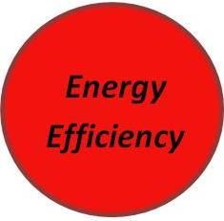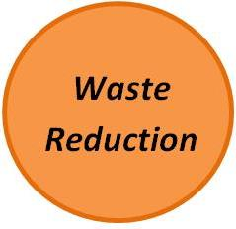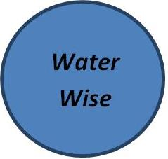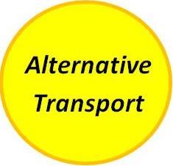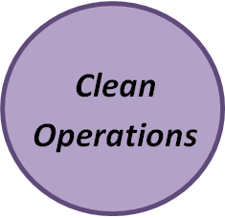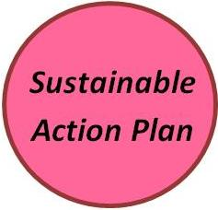

* Find alternative for Oyster Shells
* TECO energy audit (with addition)
* Starting compost collection
* Eco-friendly cleaning chemicals and soaps
* Regular air duct checks
* Working with Skypoint to get bike racks out front
* Employees encouraged to carpool
* Low-flow toilets
* Vertical garden = less food packaging waste
* Improved recycling policy
* Phase-out of paper napkins
* Phasing in LED lights
* Light sensors in bathroom
* Employee Green Practices Policy