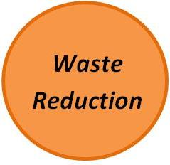

* Bike rack will be installed in front of store for Bike share
* Promotions and events during National Bike Month!
* Composting food waste though the Sustainable Living Project
* Will start carrying reusable bags for purchase
* Making recycling available to customers and using recycled products when available.
* Starting a cardboard recycling program.
* Only printing receipts for some credit card transactions and on request.
* Using recycled paper coffee cups.
* Replaced restroom towels with recycled paper ones that are easily dispensed.
* Increasing employee and customer awareness on sustainability
* Writing a formal sustainability policy statement
* Turning unnecessary lights off during the daytime hours
* Tinting windows to reduce A/C use
* Duckweed is committed to buying local when possible and reducing overall waste associated with running the business.
* Will continue to work towards being more energy and resource efficient.
* Committed to using recycled products and reducing the amount of plastic waste created.
* Increasing employee and customer education about sustainability at Duckweed and in Tampa Bay.