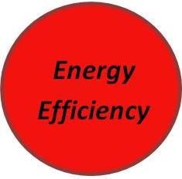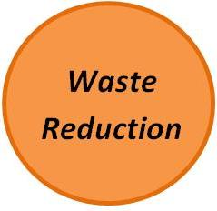

Malio’s will have TECO Energy Audit and will work to reduce its carbon emissions. Part of this aspect will include replacing all incandescent light bulbs with more efficient LED/CFL lights in order to significantly cut energy use

Malio’s has developed a Sustainability Action Plan to guide them along their journey to creating a more vibrant environment, community, and economy. Highlights of the plan include:

* Energy and Waste Reduction
* Employee engagement and sustainability training
* Environmentally Preferable Purchasing Policy

Malio’s also has begun to create a Green Team that will implement, monitor and administer the sustainability action plan. The Green Team’s other responsibilities will include:

* Employee sustainability training
* Encouraging employee and customer feedback on sustainability issues
* Manage the implementation of Malio’s Environmentally Preferable Purchasing Policy
* Education initiatives to employees and customers

Malio’s largest short-term goal is to reduce the amount of waste the restaurant sends to the trash. By installing additional bins to separate recyclables, and potentially compostable waste, Malio’s can make simple but long lasting strides toward sustainability.